CMCA Workshop Centre for Microscopy,
Characterisation and Analysis

“Scientific desktops in the cloud: Introducing the Characterisation Virtual Laboratory and the Cytometry Workbench”

Tuesday 25 July 2017  12 – 2:20 pm | Venue: Seminar Room G24, Harry Perkins Institute of Medical Research, QEII Medical Centre
Dr Lance Wilson, Senior HPC Consultant, Multi-modal Australian ScienceS Imaging and Visualisation Environment (www.massive.org.au), Monash University
Dr Andrea Holme, Senior Lecturer, Group Leader – Cytometry, CMCA
Dr Andrew Mehnert, Senior Lecturer, Group Leader – Data Management, Analysis and Visualisation, CMCA

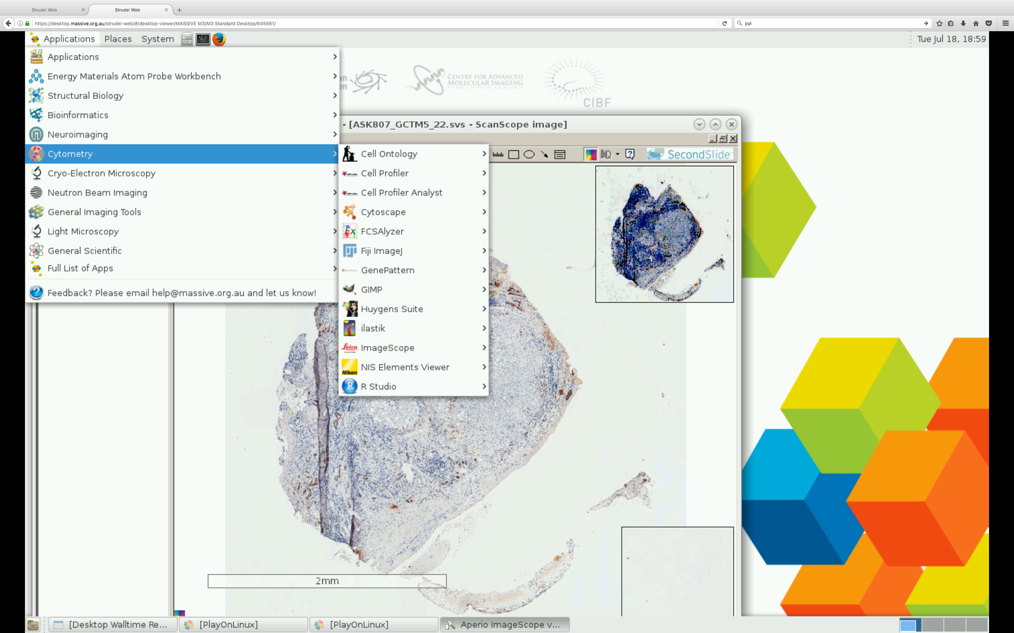
The Characterisation Virtual Laboratory (CVL) is a computer desktop in the cloud preconfigured with collections of software tools, called workbenches, for processing atom probe, neuroimaging, structural biology, X-ray, general imaging and cytometry data. The CVL is available free of charge to all Australian researchers.

In this workshop we will provide an introduction to the CVL and help you get started using it. We will also describe the various workbenches available and introduce the newly developed workbench for image/mass/flow cytometry.

Programme:
12:00 - 13:00 Introduction to the CVL
- What is it?
- Why use it?
- How to access it
- Getting your data in and out
- Feedback and requests

13:00 - 13:20 Refreshments

13:20 - 14:20 CVL workbenches
- Overview of the available workbenches
- Introducing the Cytometry workbench
- Image analysis demonstration
- Flow cytometry demonstration

All Welcome
Refreshments provided

BRING YOUR OWN LAPTOP

